SONOMA COUNTY PUBLIC LAW LIBRARY BOARD MEETING
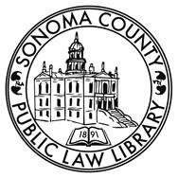
February 25, 2025
Wednesday, 12:15
Law Library, Santa Rosa
___________________________________________________________________

AGENDA

- Approval of minutes from the November 19, 2025, meeting.

- Review/approve Director’s Financial Reports for Q2 FY25/26.

- Review/approve Collection Development Policy

- Director’s Report.

- Any other business / Public comment / Adjourn.
  - Next BOT meeting: May 27, 2026, at the Law Library

