

Apricot Software User Guide:
Adult and Aging - Participant Duplicate Check Request guide

Last Updated: Jun 16, 2026
Primary Contacts | Internal Adult & Aging Programs  Allegra Wilson  Public Assistance Systems Specialist  awilson@sonomacounty-hsd.gov  Betsey Harper  Program Planning & Evaluation Analyst  baharper@sonomacounty-hsd.gov  Jonathan Love  Public Assistance Systems Specialist  JLOVE@sonomacounty-hsd.gov  External AAA Partners & Service Providers  Cassandra Denson  Administrative Aide  cdenson@sonomacounty-hsd.gov
Contacts | If the information you seek is not in this guide, or you need additional assistance, please send a support request.

Steps to request access to an existing Participant record if a Duplicate Record Warning message is displayed

- If you receive a duplicate warning message (example below) while entering the Name and Date of Birth fields, utilize the Participant Duplicate Check Request form to request access to the existing record (NOTE: do not contact the administrator, fill out the request form):

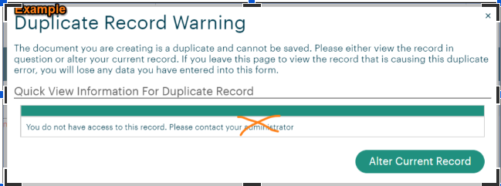
Do not contact administrator- submit
Participant Duplicate Check Request instead

- Navigate back to your Apricot main page, and submit a Participant Duplicate Check Request form.
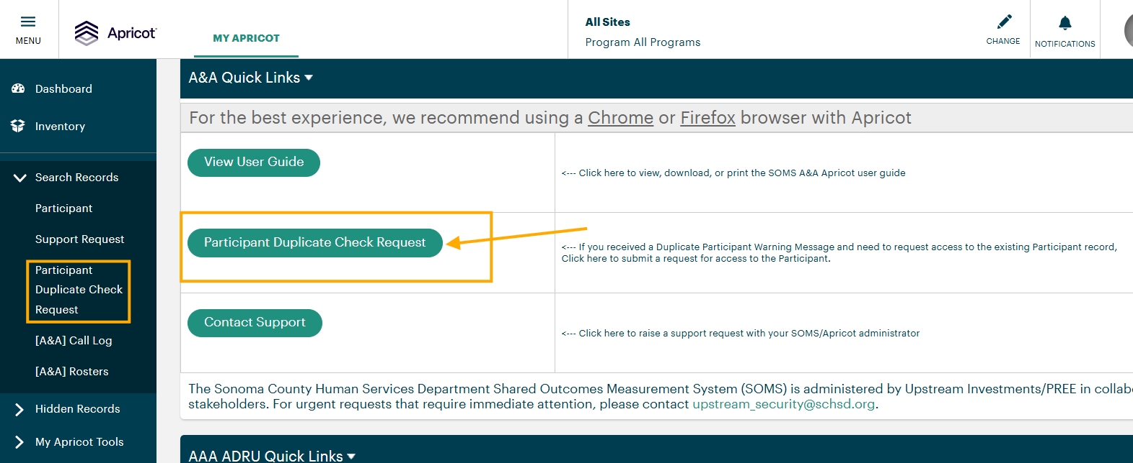

- NOTE: To initiate the ‘Participant Duplicate Check Request’ use the “+New Participant button" in the right-hand column and it will open up the below screen for completion/submittal.
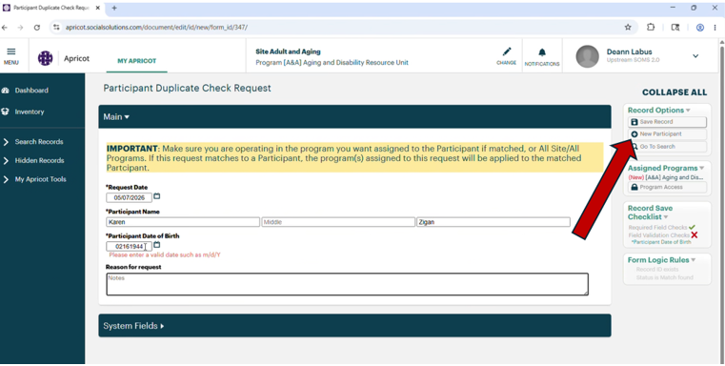

- Ensure you enter the exact Name and Date of Birth that triggered the original duplicate warning.
- Ensure the program that needs access to the record is selected in the top ribbon bar and is reflected in the Assigned Programs box when creating the Participant Duplicate Check Request form.
- Click Save Record to submit the request.

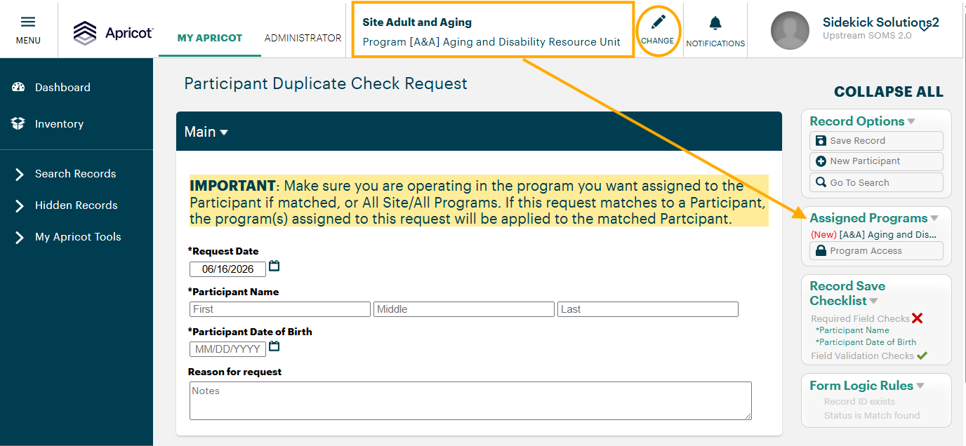
- Upon submission, an automation will run to assign access to the existing Participant record for the requested program.
  - An email trigger will be sent to the user that submitted the form letting them know of success and/or failure (please check SPAM if the email is not received within a few minutes of submission)
    - If you receive a failure message, it’s recommended that you review your ticket (bottom link on the email) to confirm the name and DOB submitted are an exact match as what you entered in the Create Participant step that triggered the duplicate warning.
      - If not, submit a new Participant Duplicate Check Request form with the correct information
      - If the information is an exact match and you still received an error, please submit a Support Ticket instead for review by an Administrator.

SUCCESSFUL NOTIFICATION
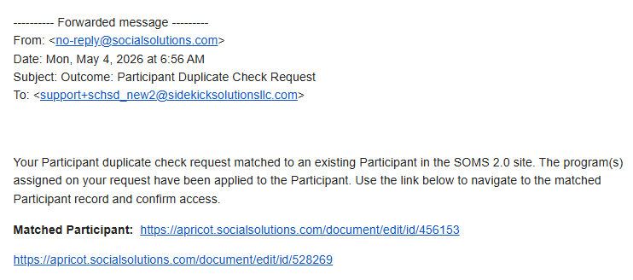

NO MATCH FOUND NOTIFICATION
